1. Bot will Enter URL - <https://planningonline.torfaen.gov.uk/>

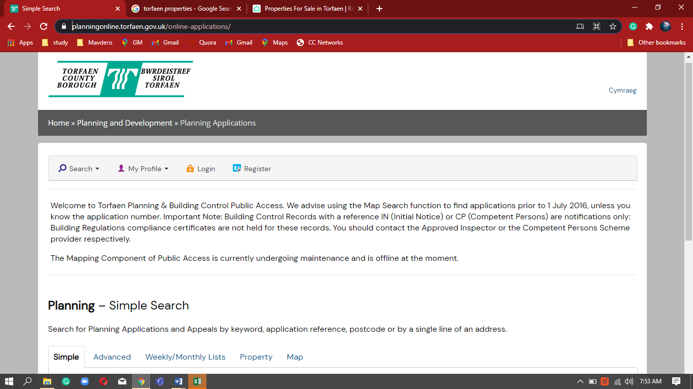

1. Bot will select “ALL” in Status

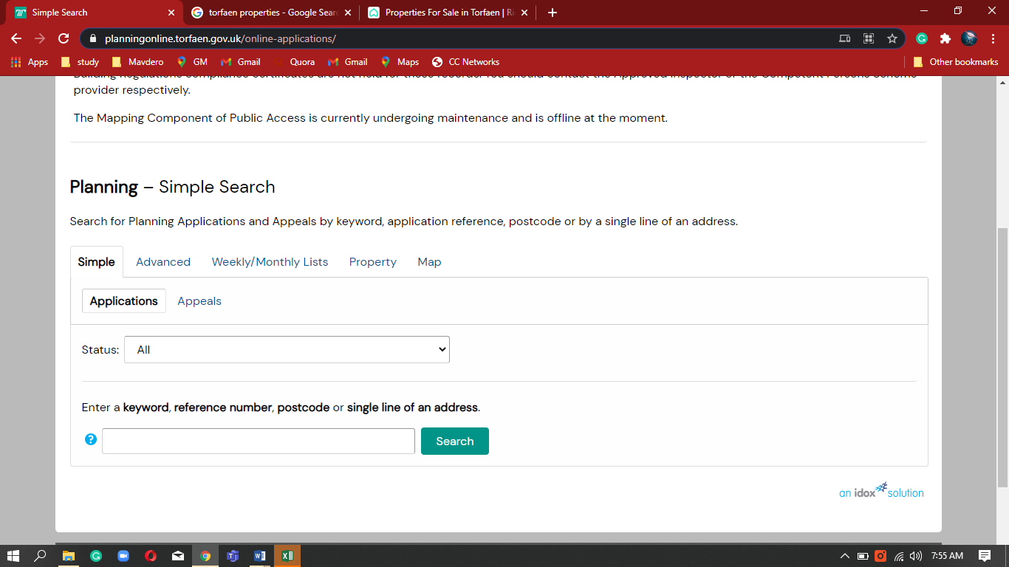

1. Bot will enter the Address and click search

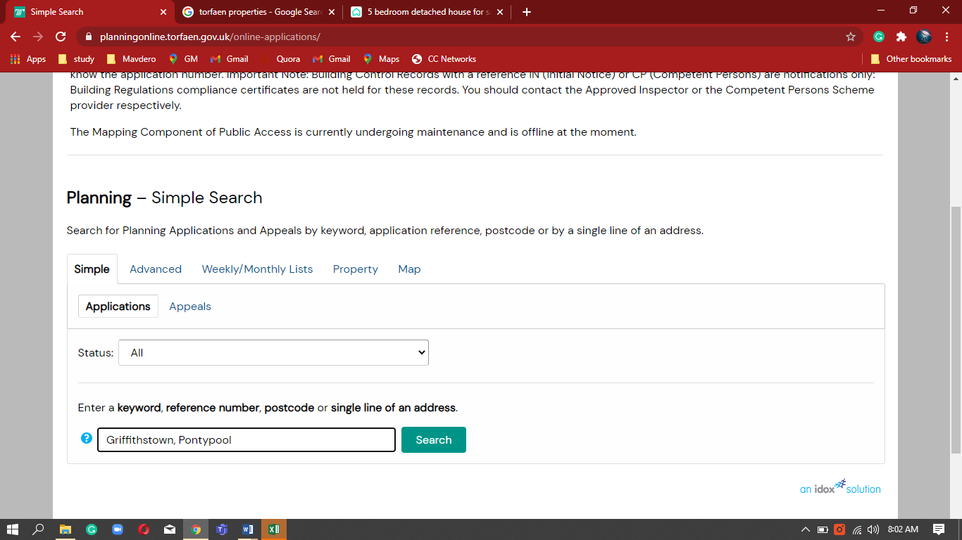

1. The Planning - Application summary will show as follow

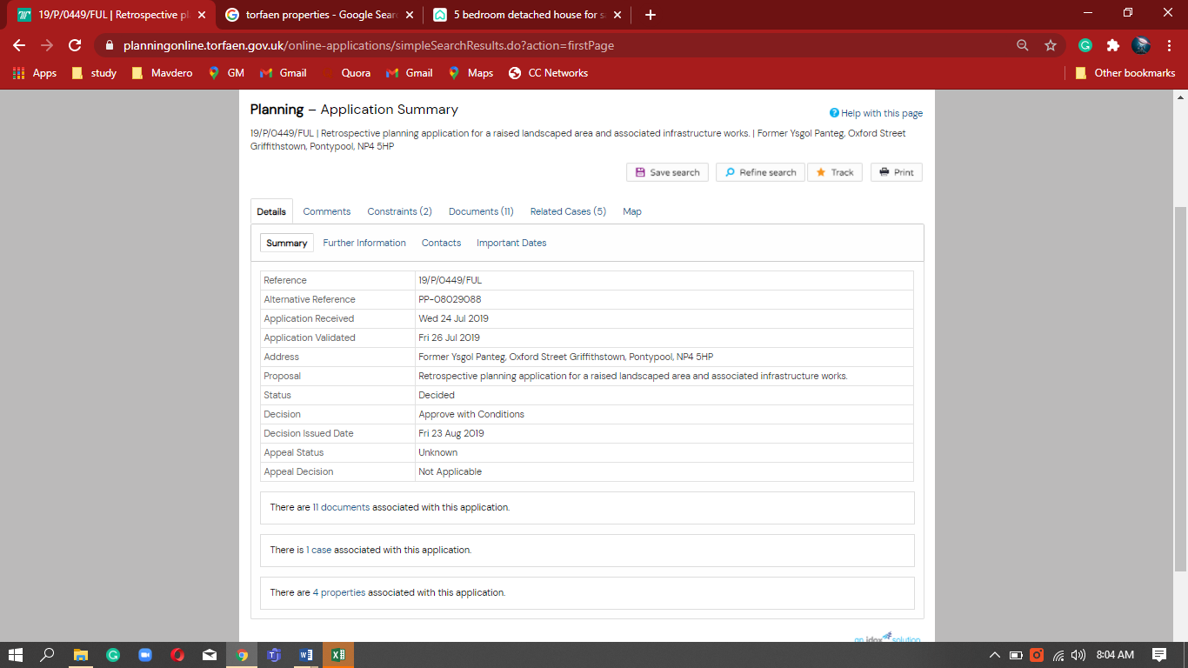

1. Bot will click the Important dates

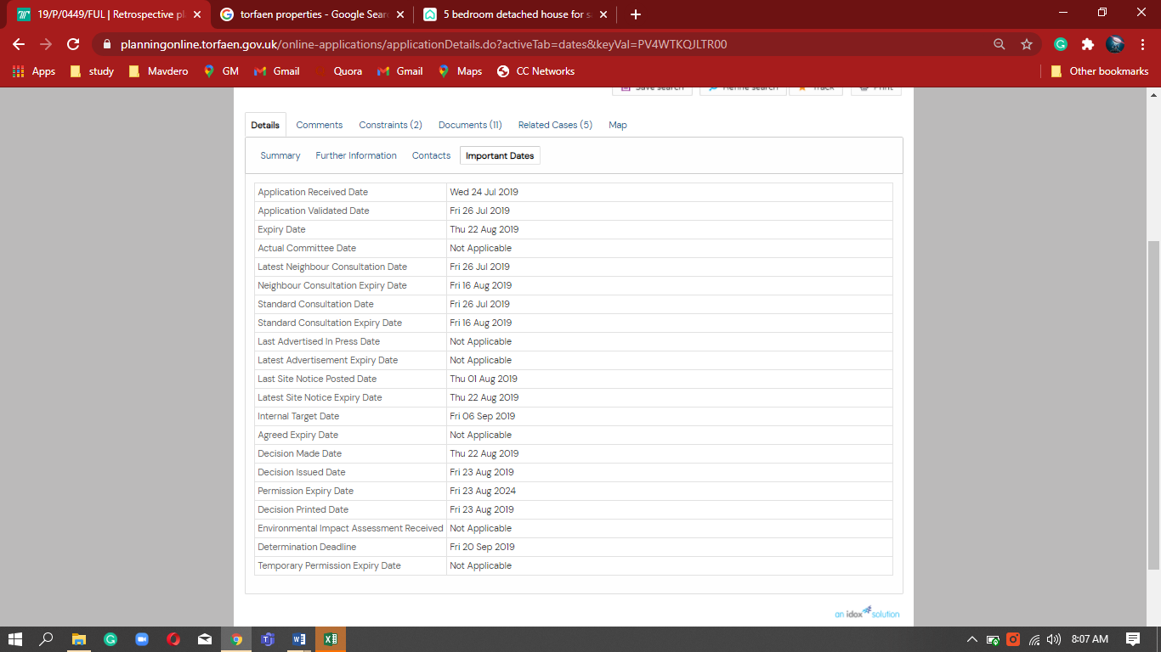

1. Bot will extract the data from Important date and populate in Excel

